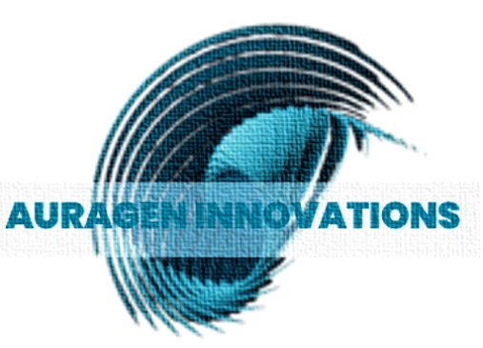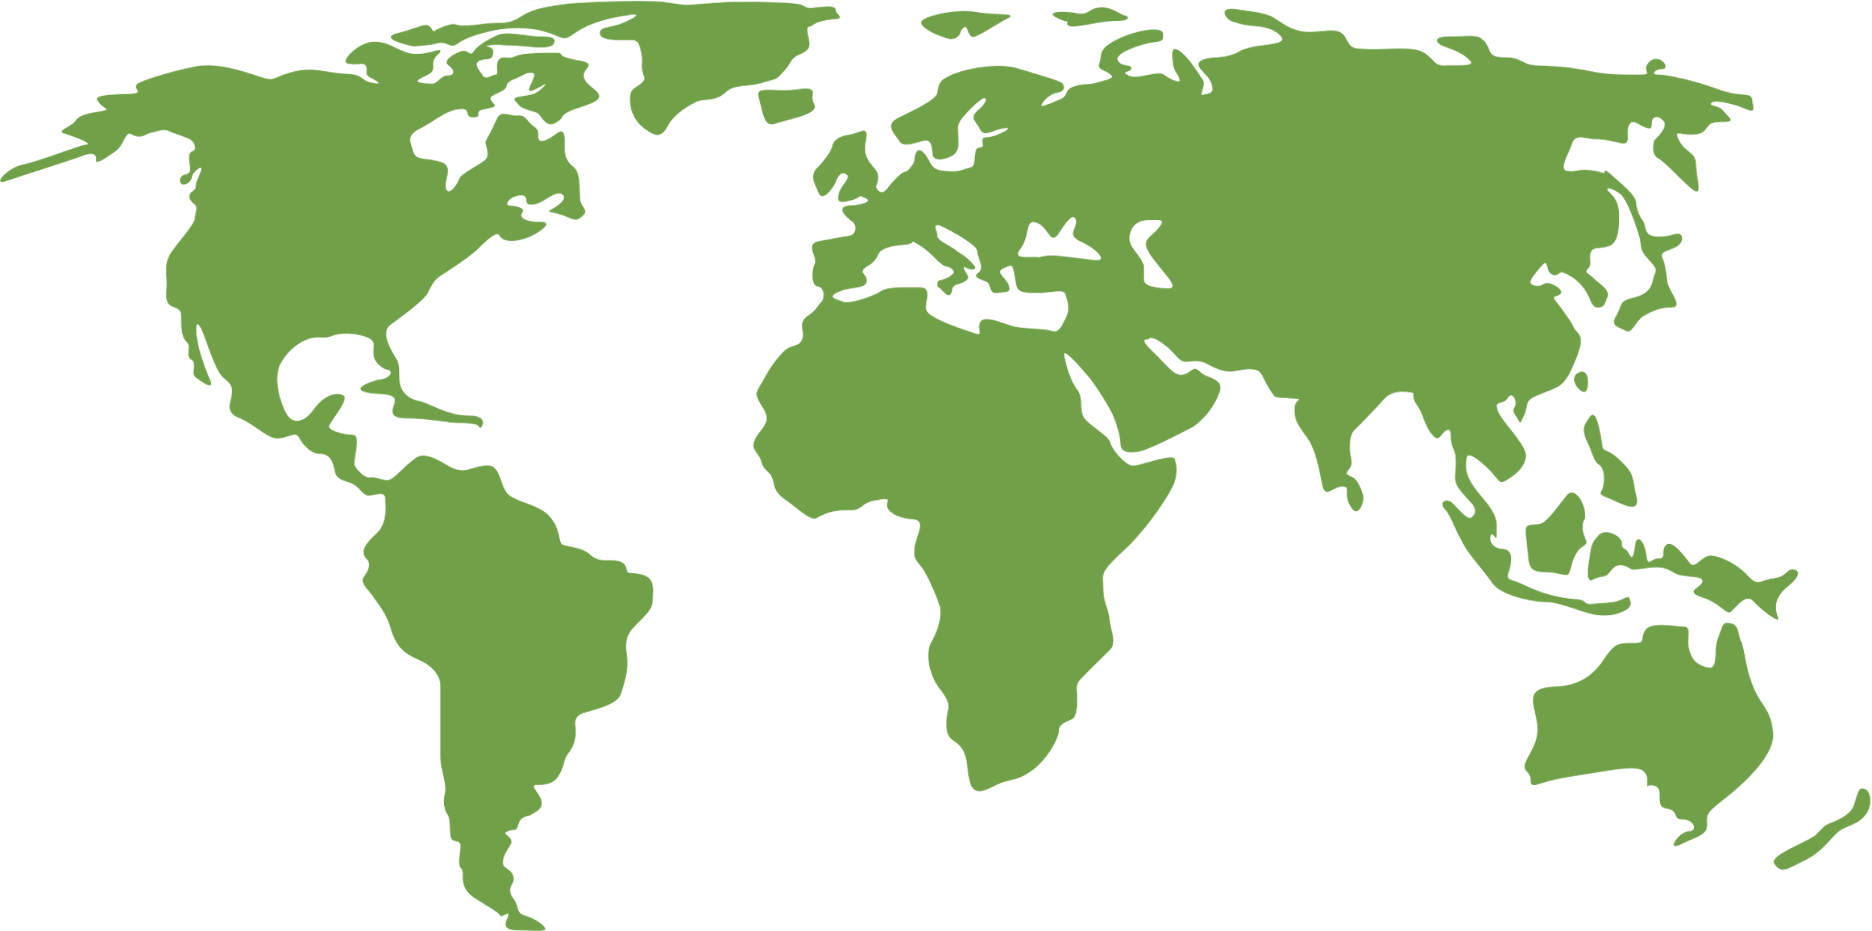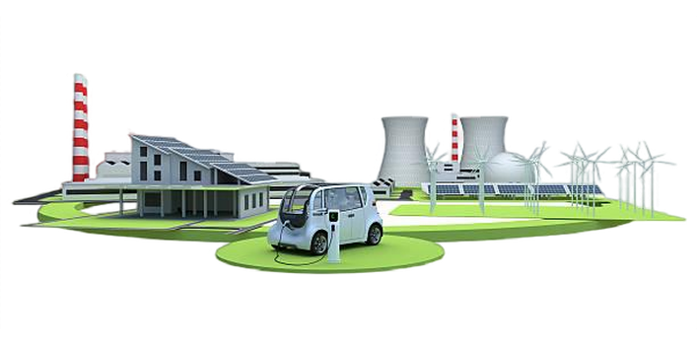

**A solution to Sub-Saharan Africa's energy access problems lies within the reach of every citizen in the world but it takes innovations & novel strategies to deliver a successful solution to the market. Utilizing our technology, users are empowered to use automated processes to solicit aid or elicit aid by engaging with each other to develop grid-independent energy sources that bring energy; access, security and resiliency to their communities.**

**As a startup, Auragen is in a position to model business processes that translate into technologies that elicit aid to those that generate energy related services & to those that solicit energy related services. These technologies equip us with capabilities that drive a service that elicit relevant services that incent both service providers & energy users reach their individual goals successfully. It is from these capabilities, that our revenue is generated; via subscriptions, commissions, data, licensing, advertising etc. as we operate as a B2B2C startup.**

Location

Market

Sub Saharan Africa is energy infrastructure deficient which impedes energy access. A majority of energy access control processes are owned by energy service companies, whose ineptitude alienate their intended audience, the energy user. The aforementioned practices have manifested into barriers that deprive 850 million Africans of access to energy.

Africa’s Trusted **Energy Access Concierge**

Business Model

The problem

The product

**Process Automation – reproducible advanced methods simplify energy access related tasks & efficiently improve return time**

**DXP – a combo of technologies & agile workflow engines, focused on dynamic sequential fulfilment of tasks relevant to users**

**CRM & CAM – relationships that allot capital to users for implementation of customer goals**

**Empower Users – give users control, let them resolve their own energy access pain-points through our platform**

**Acquire – let users put our platform to task & develop the energy infrastructure they need**

**Manage – with a variety of assets, users are motivated to generate energy individually or as a group to store or sell energy using our tech**

The Solution

**Sub Saharan Africa**

**13.1 bn**

**$**

**7.86 bn**

**$**

**tam**

**som**

**11.1 bn**

**$**

**3.93 bn**

**$**

**sam**

**ems**